Clothing Guidelines for the Refugio Militia
1828-1836
by Wade Marcum

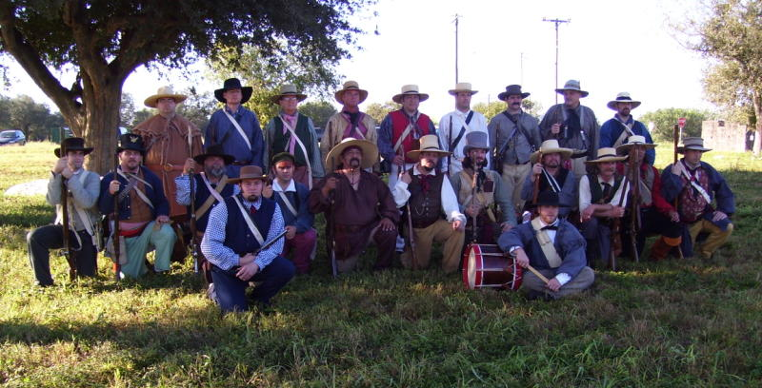

“So early in the following year, 1827, I started out from Hopkinsville, Kentucky, with all my worldly possessions, consisting of a few dollars in money, a change of clothes, and a gun, of course, to seek my fortune in this lazy man's paradise.”- Noah Smithwick

“we used then to hear fellows with 'store clothes' on lamenting the crude state of society and consoling themselves with the assurance that the 'better sort' would come after a little.”-Noah Smithwick

“We are all most naked as we are cuting Up tent cloth to make us Panteloons & Every man is his own Taylor in this Army & a good many of us are bare footed & worst of all the the Schooner that was bringing provision & clothes has been wrecked.”-J.C. Logan

Author’s Note
Just a note before beginning, this is by no means the FINAL say on clothing regarding the Refugio Militia of the period between 1828-1836. This is simply a primer to help people coming into the hobby, and give them a good direction to start their research. People that have been involved in the hobby for a while will probably find the information here simple and basic. That is okay. This is a basic guide, and as new materials become available some of this material may become outdated. However, at the time of this writing, this is based on some of the best information that we have to date. Remember to continue to research on your own, and always ask “why?” That is how we progress. More and more sources are continuously coming to light. There are several good sources listed at the end of this work. Read them and make your own discoveries. With that said, I hope that this is a useful tool for you.

Introduction
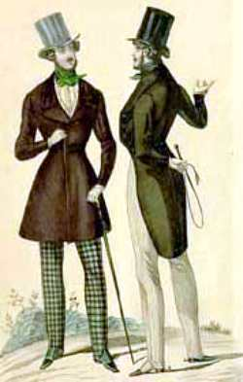
Texas during the period of 1828-1836 is a fascinating area to study and reenact. There were many different cultures, social classes, technologies, and ideas coming together and sometimes violently colliding. These forces can be seen even in the dress of the people that lived in Texas. There were many influences on a person determining how one dressed. These influences ranged from where a person came from, their culture, their station or class in life, finances, availability of clothing, or how long you had been in service or on campaign. In some cases a person would have several, if not many of these factors determining his or her dress.
In the American Revolutionary War period, the style of clothes marked a person as an aristocrat, shop owner, or “middleing sort”. A person that had the means wore only the latest fashions that were tailor made to him or her. This had changed by the 1820’s and 1830’s with the rise of Jackson and “the common man”, the industrial revolution, and advances made in clothing production. Tailor made clothing was still available, and a sign of the wealthy. However, ready made clothing in the latest styles had also become available and gave rise to the descriptions of Americans and “their citizen’s outfits.” Of course this was said sarcastically since many of the garments were pre-made and ill fitting.

One note on clothing and styles in Texas. Many first person accounts recall that the people of Texas wore their clothing until it turned to rags. Items would be repaired and patched until it became impossible to use the garment. Of course determining when the garment was no longer useful varied according to one’ social class. Therefore, worn and patched clothing would be very appropriate for your impression.

Status and Class in Texas
Even though the late 1820’s and the 1830’s occurred during the height of the Age of Jackson and the Common Man, there were still class distinctions evident. Even though social lines were somewhat “blurred” in Texas, they still existed to some degree. There were four types of class in the American South, and at least three from the northern states as well as Europe during the time period we portray.

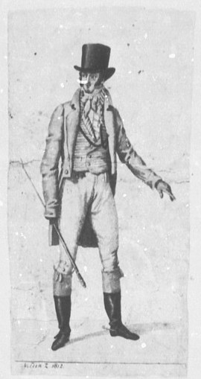
- Upper Class/Aristocrats
Members of the upper class were made up mostly of the wealthy landowners (plantations), and those that had large ranches, doctors, large business owners, ships owners, and lawyers. They accounted for a small percentage of the population at only 2 %. These men usually had an education and may have even attended a university. A person could be considered Upper Class even if he did not own land, if he came from an established family in the Sates or in Europe. A person could rise to the Upper Class through notoriety (Sam Houston, Jim Bowie, David Crocket for instance). These individuals usually set the standard for dress wearing the latest fashions. However, since Texas was a frontier community, the upper class styles may have lagged a few years behind other areas (Paris, London, and New York). Yet Refugio was near a costal port, and may have been able to get new fashions from New Orleans. Oftentimes referred to as gentlemen, these men generally set their honor above all else, and would fight duels with fellow aristocrats, or drub lower class individuals with their canes, to protect that honor. In militia companies, these men would often be the elected officers, but not always.
“Most of the men I have mentioned were men of means, many of them having slaves with which they had already opened up quite respectable plantations.”-Noah Smithwick discussing the early settlers and colonists of Texas
“Around some twenty or thirty camp-fires stood as many groups of men, English, Irish, Scotch, French, Germans, Italians, Poles, Yankees, Mexicans, all unwashed, unshaven for months, their long hair, beard and mustaches, ragged and matted, their clothes in tatters, and plastered with mud. In a word, a more savage band could scarcely have been assembled; and yet many-most indeed were gentlemen, owners of large estates, distinguished some for oratory, some for science, and some for medical talent, many would have, and had, graced the drawing-room.”-Benjamin Cromwell Franklin describing men on the San Jacinto campaign.
- Middle Class
The Middle Class in the 19th century was much smaller than what it has become today. Approximately 18 % of the society were members of the Middle Class. Middle Class members were usually composed of shop keepers, ships captains, teachers, mid-sized farm owners with a few slaves, and the clergy. These people were usually educated to the point that they could perform their jobs, but may not have been overly educated (such as having learned Latin). They typically dressed in the fashions of the day (once again Texas is a frontier community and styles may have lagged a bit), but the materials and tailoring would have been less than what was found in the Upper Class. These men sometimes held rank in militia companies either as officers or NCO’s.

- Lower/working Class
This was by far the largest class at nearly 80% of the entire population. These were the working class that performed the menial jobs of the time period. Many either had a rudimentary education or no education at all, depending upon where they had spent much of their childhood. These were usually the small farmers, farm hands, day laborers, “mechanics”, and ranch hands. In Europe and the eastern United States, these individuals were separated by a vast social sea from the other classes. However, in Texas it seems that these class distinctions may have been blurred to a small degree allowing for more interaction between the groups. Lower Class clothing often reflected their social status and would be patched, ragged, and worn. Most members of a militia company would come from this class.

- Slaves
Slaves of course were the bottom of Southern Society, and in Texas were “legally” indentured servants for life, or had been forcefully contracted to serve their master since slavery had been outlawed in Mexico and her states in the 1820’s. In the deep South, there were areas where the slave population was 55% of the entire population! Their clothing would have been VERY DIFFERENT from their masters, and would be very worn and ragged. They sometimes accompanied their masters on campaign in the role of servant.
“Jesse Thompson, living on the San Bernard though possessed of a number of slaves, devoted his attention mostly to stock…One of his slaves, Mose, impatient for the promised freedom, ran away to Mexico to obtain it, but he soon wearied of "husks," and, returning voluntarily, surrendered himself to his old master, preferring slavery under Thompson's lenient rule to freedom in Mexico.
The negroes soon became aware of the legal status of slavery in Mexican territory…Jim, one of McNeal's slaves, openly announced his determination to leave, and, acting on the impulse, threw down his hoe and started away. Pleasant McNeal, to whom he communicated his intention, ordered him to return to work, but Jim went on, whereupon Pleasant raised his rifle. "Jim," said he "if you don't come back I'll shoot you!" Jim, however, kept on and true to his threat McNeal shot him dead.”-Noah Smithwick
In the Tejano ranching community, there were some variations in class structure, but on the frontier they had basically evolved into three classes: Upper, Middle, Working classes. The percentages were nearly identical to those of the United States.

- Upper Class/Landowners/Landrones
Originally descendants from the Spanish nobility, by this time they were the large land owners that had either been granted land, or had inherited it through family ties. Since they were the head of the ranch, and thus the head of the people that worked on it, these people were very similar to aristocrats or other titled people. This was a VERY small percentage of the general population yet controlled most of the local power. They usually held some sort of political position in the Mexican rule (acalde, judge, etc…) and had ties to Mexico. However their was a split between Centralists and Federalists within this class. Within the traditional Mexican “militia” organization, these men would help outfit and provide mounts for the men and serve as officers. They usually were up to the latest fashions from Mexico City.

“There were no horses to be had, but we were directed to a wealthy old Mexican ranchero over on the Guadaloupe who had horses galor.”-Noah Smithwick

- Middle Class
There existed a small middle class within the Tejano communities of Tejas. There were shopkeepers and owners, small farmers, and others associated with the middle class (as in the US). However, the Tejano community was largely a ranching community. Serving under the wealthy landowners were the ranch-hands that were held in high esteem by the local population. They were known as vaqueros and prided themselves in their abilities on horseback. Even though they may not have had the money that other middle class people had, they were looked up to by the lower class. Vaqueros wore a distinct type of outfit that was copied by other members of the middle class as well as some of the upper class.

“Martin De Leon had settled his grant with Mexicans, most of them being his peons and vaqueros.

“The vaqueros rode in among them, carajoing and swinging their lariats, the horses reared and snorted, and we concluded walking would be pleasant pastime compared to riding such steeds.” -Noah Smithwick on obtaining some horses from a wealthy rancher

- Lower Working Class/Peons
These were by far the largest percentage of the population. They served in a variety of jobs (working on small farms, day laborers, cooks, tortilla makers, etc…). They were typically clothed in the bare essentials: white light trousers, shirt, hat, and sandals. However, clothing variations did exists especially due to the types of employment the person might be in. A low class individual may rise up to the middle class, if they obtained a good job or began working their way up on one of the large ranches as a vaquero.

“In spite of the abject poverty of the Mexican peons, they extracted a good deal of enjoyment from life. The men worked out in the hot sun all the week, with only thin cotton trousers on, and on Saturday night donned a shirt and went to the fandango perfectly happy if they had a few cents with which to buy a cup of mescal and a cigarette.”-Noah Smithwick

Types of People around Refugio
Refugio was located in one of the Irish colonies that had been established under the Mexican Immigration Laws of the 1820’s. It was located in a prime spot near the San Antonio river near the coast which allowed it to receive many goods from New Orleans. This was also one of the first towns that many immigrants passed through after getting off of their ships at Copano Bay.
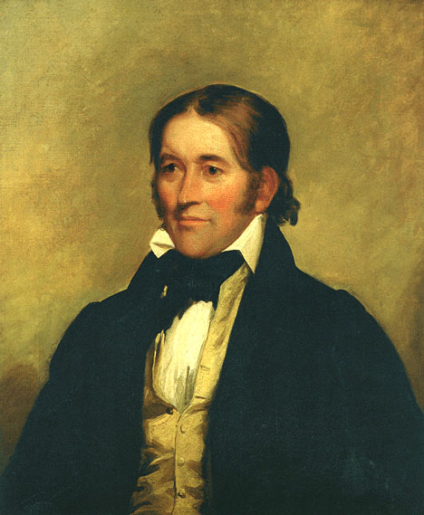
Many of the residents of Refugio were Recent Irish immigrants, or Irish or Irish descendants that had been living in the United States (especially in the New York area) and had decided to immigrate to Texas due to restrictions and prejudice that was beginning to arise in the US toward the Irish. These people quickly found a home in Texas where their Catholic religion was accepted rather than despised. Originally, they were staunchly pro-Mexico, but as Santa Anna continued to consolidate power, many wanted change if not out right independence. However, many did not want to join the United States if independence was gained.
The other large portion of the population came from the local Tejanos. Many of these people had owned or worked the land in the area for generations. They were generally divided between Centralists (people that supported Santa Anna and a centralized government) and Federalists (people that wanted a return to the Constitution of 1824 and supported a government divided equally between state and federal powers).
The people which made up the Refugio Militia had a variety of jobs. There were many ranchers and stock raisers especially among the Tejanos. Upper class Americans were generally large land owners with plantations. Some farmers and shopkeepers existed among the middle class Americans and Irish immigrants, and blacksmiths and other semi skilled persons such as carpenters, and day laborers made up the lower class.

Materials
The materials that made the clothing of the people that lived in Texas were greatly varied. There were two sources for clothing material during this period; either it could be purchased from a store, or it would be made by the family or individual. Early settlers mention clothing made of buckskin, homespun, wool, cotton, linen, and linsey. These were materials that were easy to obtain, or make from available sources. Early sources from the 1820’s indicate that there were very few looms or spinning wheels initially, and clothing was worn until reduced to rags and then replaced by leather. Once colonization began in earnest crops of cotton and flax were grown, sheep were raised for their wool, and spinning wheels and looms were made or found their way into the colonies. Much of the clothing from the late 1820’s and early 1830’s (and even later depending on where one lived) was referred to as homespun and was usually of a course weave and simple colors.
When towns began to grow and more items were imported, cloth on the bolt and ready made clothing straight from the United States or elsewhere would have been available at the local shops. By this time the Industrial Revolution was in full swing (especially in the cloth industry) and many different materials and fabric could now be produced easily and at a lower price, which meant that prices for materials dropped allowing average Americans to procure material that they had been unable to afford before. Roller printing had been developed, which had replaced the older, time consuming, and expensive block printing. This form of printing was easier, and allowed for more elaborate prints to be made at a cheaper cost to the consumer, and since Texas is a costal land this allowed for trade with major cities such as New York and New Orleans. Therefore by the mid 1830’s the latest fashions, or materials could be brought into Texas without trouble. However a person’s location and finances would still determine how much of these items they could obtain.

“Miss Wilkins was an expert needlewoman and we old bachelors found much need of her services, almost all clothing then being made to order; consequently we felt that we had just cause of complaint against the alcalde when he selfishly appropriated our fair seamstress, leaving us with enough ready made clothing on our hands to stock a small clothing store.”

“The bridegroom, being a merchant, had on "store clothes," but that kind of apparel was not de rigueur. There were many homespun suits and the old reliable buckskin was also in evidence.” -Noah Smithwick speaking about an early wedding (ca. late 1820’s)

THE FOLLOWING ITEMS WILL BE GIVEN A RATING SYSTEM AS TO HOW COMMON THEY PROBABLY WERE AMOUNG THE PEOPLE THAT MADE UP THE REFUGIO MILITIA. THIS IS BY NO MEANS A FINAL SAY. JUST A MEANS FOR NEWCOMMERS TO DETERMINE HOW COMMON AN ITEM MAY HAVE BEEN IN THE REGFUGIO AREA……

10-BEING VERY COMMON/UNIVERSAL
5-SOME WOULD HAVE BEEN SEEN
1-HARDLY ANY WOULD HAVE BEEN AROUND

Clothing Types

Headwear
People of the early 19th century generally kept their heads covered while outdoors or in public. There were several popular styles available to men during this period in Texas. They type of hat that one wore was generally influenced by their status and job in the community.

“Here a broad-brimmed sombrero overshadowed the military cap at its side; there a tall "beegum" rode familiarly beside a coonskin cap, with the tail hanging down behind, as all well regulated tails should do.”-Noah Smithwick

Forage Caps or Caps-6
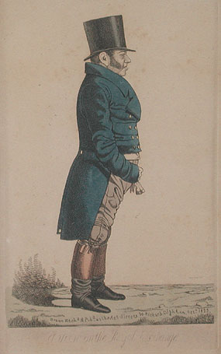
Description: Generally made from cloth or oilskin, the wheel cap had become the head covering for young boys and men that were known as “mechanics” such as blacksmiths, carpenters, etc…. These hats slowly gained popularity with the general population. The cap looks similar to a policeman’s dress cap. It has a round two piece top, stiffened sides known as a band, and usually a leather “peaked” visor. This type of head gear had been adopted by the US military in the 1820’s for field use.
Materials: Oil Cloth, Wool, Jean Cloth, possibly other types of material
Who Wore It: Young boys, working men of the middle class, hunters, travelers, immigrants, and other lower class people.

Top Hats-4
Description: Top Hats (also known as stovepipes and beegums) were the dressy and stylish hat of men during the 1820’s, 30’s, and even into the 40’s. They usually had a short 2-3 inch rolled and trimmed brim, with sides that were around 8-12 inches tall, with a slight bell near the crown.
Materials: They were usually made of beaver fur that had been felted, sometimes silk, or other cheaper felts. However, there were top hats of a beehive pattern that were made from straw, and seemed to be quite popular to wear in the summers during the day.
Who Wore It: Initially an item of dress for the upper class, the style was also worn by people of all classes, but of cheaper material and usually well worn or even patched.

Planters Hats-4
Description: A planter’s hat was a style that had found favor in the southern aristocracy (thus the name). It was generally a wide brimmed (4 inches or more) hat that offered protection from the sun, with a crown that belled out somewhat similar to a top hat. These hats were of various colors, but usually of a lighter color due to the intense sun. Favorite colors included various shades of brown, gray, sometimes black, and possibly even white (at least when new).
Materials: Felted fur or sometimes beaver, also straw
Who Wore It: This type of hat was worn by many upper and middle class people in Texas due to the protection it offered from the sun. It would have been virtually unknown to recent immigrants, as this style was generally seen in the U.S.

“Slouch” Hats-7
Description: The slouch hat was a simple wide brimmed hat, with a normal rounded or even flat crown. There was no bell in the crown, and these hats were often shaped to the whims of the owners. The brims could vary from a short 2 inches to 4 or even a little larger. Popular colors were black and various shades of brown and they were usually made from a cheap fur felt. They became known as slouch hats due to when they were exposed to rain and weather, the brims would often “slouch” or drape down.
Materials: Cheap fur felt, or sometimes straw.
Who Wore It: These were widely worn by many lower class people. They were relatively cheap, and offered the wearer protection from the rays of the Texas sun. After their initial head gear wore out, this would have been an item quickly adopted by new immigrants. Vaqueros also wore a similar hat, but it generally had a flat crown which inclined inwards.

Fur Hats-1
Description: It cannot be denied that there were fur hats being worn in Texas during the period we are reenacting. Several period sources mention men with fur hats with tails attached. They may have had a leather peaked visor attached to them, but rarely would a full face of a creature be displayed on them. If a tail was attached, it would be attached to either the top of the cap or towards the back.
Materials: Varying types of furs, usually of small animals such as raccoon or “polecat”( skunk) or possibly even larger animals.
Who Wore It: Typically an item worn in cold or cool weather, this was an article that was worn by hunters or people of a “lower” social standing during cold weather. Some reports say that Crockett may have worn one, but this was generally believed to be for his political campaigning, cold weather, or living up to his image. Research your character before investing in one of these items.

Period Descriptions:
“During a visit to the home of Col. Bell, my head covering a fur cap which I had deposited on the floor beside my chair…”

“With a number of other men I was standing on the porch of Elisha Robins' boarding house when a grotesque figure surmounted by a coonskin cap sauntered slowly past the group”- Noah Smithwick

Outer Garments
Generally speaking, outer garments were usually worn at all times by any man with standing in the community or as a means to protect other clothing. During this time, dark colors (black, brown, blue, green, maroon) tended to be more popular for dress outerwear, but light colors (beige, white, and other light tones) were not unknown especially in the hot Texas sun. Sleeves were generally tight in the upper arm, and the cuffs extended down to the wearer’s knuckles.

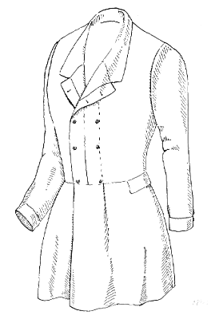
Frock Coat-3
Description: The frock coat was an item that had evolved from cold weather wear, to one of evening dress for the upper class elite. Generally the coat had a shawl, also called a rolled or horse collar, with flared skirts (the area of the coat below the waist). The sleeves could have a small “puff” on the upper portions at the shoulders. This coat could be single or double breasted, and was made in a wide variety of materials and colors. This type of coat had just begun to gain popularity among the wealthy in the States during the late 1820’s and early 1830’s. By the 1840’s it would come into general use among the population.
Materials: Wool, linen, linsey, cotton, jean cloth, and very few out of buckskin (with a slight variation in tailoring and with little short fringe)
Who Wore It: This was a garment typically worn by Upper and a few Middle class American or European immigrants. Finer examples were worn by the upper class. Middle class examples would have been slightly lesser quality. Some lower class individuals may have had access to these coats, but they would have been of much lesser quality unless an item of a hand-me-down nature.
Period Descriptions:
From Washington Irving’s A Tour on the Prairie describing mounted ranges in 1832: “They were a heterogeneous crew; some in frock-coats made of green blankets, others in leathern hunting shirts…”-Washington Irving

Tail Coat-7
Description: The tailcoat was the everyday coat of the 1830’s. Originally, an item of formal wear, it was now the standard coat of the day. It usually featured a shawl, or horse, collar, and could be either single, or more commonly, double breasted. The front of the coat terminated near the fall of the trousers and was cut straight across, then tapering into the distinctive tails which gave the garment its name (much like a tailed tuxedo today). Typically the tails terminated near the back of the wearer’s knee. Sometimes the sleeves at the shoulders had a slight “puff” to them. These coats could be of a variety of colors (usually a dark tone), with black reserved for nighttime formal wear. These coats were one of the items that were being pre-made (not tailored) for use by the general public. Europeans often remarked that even the poorest American or Texian colonists wore this type of coat that was generally worn by European aristocrats.
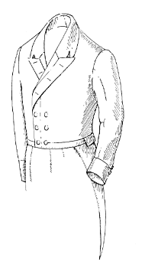
Materials: Wool, Linen, Linsey, jean cloth, or cotton
Who Wore It: Popular item of dress for men during the period. Popular with American and European immigrants. Quality varied according to the class of the wearer.
Period Descriptions:
“As a rule, and umbrella, straw or felt hat,…cotton dress coat with tails, trousers with straps, white socks, fine patent-leather shoes that are partly without soles and have cut-out upper, a faithful horse, a long rifle, and one spur on the right foot are signs of an American.”-Steinert commenting on the dress in Texas

Coatee-3
Description: This type of outer garment was very similar to the tailcoat with the exception of the tails being shorter. These types of coats found popularity with European immigrants as well as working class Texian colonists.
Materials: Wool, Linen, Linsey, jean cloth, or cotton
Who Wore It: Working Middle and lower class, as well as European immigrants.

Roundabout or Monkey Jacket-7
Description: The roundabout or monkey jacket was a working man’s garment. It offered the wearer a way in which to be “civilized” by wearing an outer garment yet did away with most of the extra tails or body that might inhibit a man going about a day’s labor. The roundabout could have either a standing collar (more of a military look during this period) or the shawl collar found on other garments. The body of the roundabout was cut similar to the frock coat and tail coat. However, the body terminated in a straight line all the way around at the wearer’s waist. These types of coats where standard “fatigue” wear for most armies of the time.
Materials: Wool, Linen, Linsey, jean cloth, cotton, or very few in buckskin
Who Wore It: Working Middle Class and Lower Class. These coats were also very popular with sailors of the period. Military cast off’s may have been available since the army had adopted its use in the 1820’s for fatigue wear. These were also popular garments for slaves, but these would have been at much lower quality. Buckskin ones may have been worn by ranchers or people constantly riding through the brush, but fringe would have been minimal.
Period Descriptions:
“(Burleson) wore a somewhat faded, blue home-spun round-jacket and pantaloons. He carried no sword or other arms, except a pair of small pistols in his belt. Sherman had a much more trim and military appearance. He wore a blue cloth round-jacket trimmed with silver lace, and a handsome dress sword suspended at his side.” –James Kuykendall describing Burleson and Sherman during the Runnaway Scrape

Vaquero’s Jacket 2 for Anglos and a 7 for Tejanos
Description: A variation of the roundabout was the vaquero jacket. These jackets were very popular with Tejano ranchers and may have been adapted to some degree by Texians that were working closely with Tejano ranchers. These jackets were very similar to the roundabout with the exception that many did not fully close in front, and may have had decorating ribbon or trim around the waist, jacket opening, and/or cuffs. The cuffs were usually left open for ease of movement.
Materials: These were usually constructed from wool or buckskin and had contrasting trim.
Who Wore It: An item usually associated with Mexican horsemen and ranchers. It is possible a FEW Anglos or Texians may have adopted its use.
Period Descriptions:
“Smith had on the Mexican courier’s fine suit of leather, all braided and fixed up in uniform style. A broad Sombrero, a heavy bead band and trinkets attached, fine shoes and socks….” The courier “had on Deaf Smith’s old ragged coat and ragged pants.” –Moses Bryan describing Deaf Smith. Smith was probably wearing this captured clothing as to not be captured by Mexican scouts.

Hunting Frock-3
Description: The “classic” American garment of America’s pioneers on their journey westward. At least that is what we think today, and perhaps (by the popularity of the garment during the period) the settler’s of Texas felt the same way. The hunting frock, in its basic form, was similar to a shirt made large enough to cover other garments, with an opened front. Attached to the neck and draping over the shoulders, was usually one or two capes with fringe. Collars varied from a simple falling collar to a stand up collar found on shirts of the period.

Materials: The hunting frock
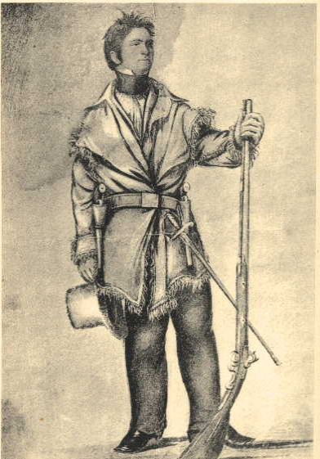
could be made from a variety of materials; including buckskin (with short self fringe), linen, cotton, jean cloth, and linsey. They could also come in a variety of colors, sometimes having the fringe a contrasting color to the body of the garment.
Who Wore It: Worn mostly by lower class American hunters. Typically viewed as a hunter’s garment, however wealthy or middle class American individuals going on hunts, as well as military service, would don this garment for its serviceability, distinct association with the American hunter, and the romanticism associated with it during the period (ie…Hunters of Kentucky, Leatherstockings, etc…).
Period Descriptions:
“The writer was resplendent in a brand new buckskin suit, consisting of hunting shirt, pantaloons and moccasins, all elaborately fringed.”-Noah Smithwick

“They opened a heavy fire, which wounded Buchanan in two more places slightly, and pierced Bowie’s hunting shirt in several places without doing him any injury.”-Rezin Bowie referring to their fight with Indians in 1832.

Overshirts-6
Description: The bib overalls of the 18th and 19th centuries also sometimes called a hunting shirt. This was a garment designed for a man at work. It was generally constructed along the same lines as a shirt, except being roomier in order to fit over one’s clothes to protect them from the dirt, grime, blood, or other elements that would damage an outfit. Popular with individuals that worked outdoors in both the United States and Europe, the overshirt was also a favorite item taken when in militia service.
Materials: These were often constructed from light wool, linen, linsey, or even cotton and could come in a variety of colors or checked patterns. There are some references to ones made from leather, but these were generally located further away from the settled areas.
Who Wore It: Seems to have been a common garment for anyone doing manual labor outdoors, or performing hunting or military service.

Vest
The vest was an item worn under the primary outer garment, sometimes. Not everyone would wear a vest under their coat, especially if the coat was buttoned up, the person was of low class, or the weather was very hot. Generally speaking if a vest was worn, it would be with a frock coat or tailcoat, or sometimes under a roundabout. However, VERY RARELY would a vest be worn without an outer garment. Vests could vary from very bright colors, floral or checked patterns to plain color or simple woven patterns. There were two popular (not saying ONLY two) styles of vests during the period.

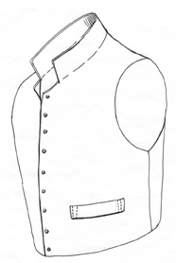
High or Standing Collar-4
Description: This was an older style of vest that had come into vogue around the time of the War of 1812 and lasted through the 1820’s. It was still being seen in some areas along the frontier and into Texas. This vest had a high closure in the front that ended in a collar that stood up around the wearer’s neck.
Materials: Wool, Jean cloth, Cotton, Linsey, and perhaps linen. Since these were of an older patter, they tended to be of single colors or simple print.
Who Wore It: Vests were usually worn by men of some means, or recent immigrants from Europe or the States. However, these older styles may have been found on individuals of a lower class made out of cheaper material and being homemade.

Shawl Collar-7
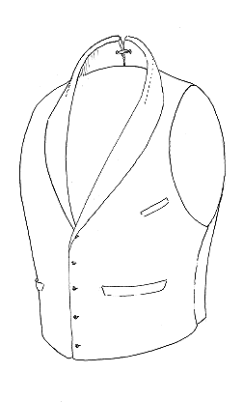
Description: This was the new fashions in vest coming in toward the end of the 1820’s and beginning of the 1830’s. It had a lower closure in the front, usually consisting of around 5 buttons for a closure. The vest allowed the man’s upper shirt (which by this time had pleating) to be seen. The collar of the vest was what was known as a shawl collar or rolled collar.
Materials: Wool, Jean cloth, Cotton, Linsey, and perhaps linen. Could be of a bright color and/or pattern.
Who Wore It: With the Industrial Revolution, many men from different social levels could obtain a vest of this style either tailor made or pre made. However, the quality and fit of the vest would be determined by the wealth of the individual.

Pants
Pants, trousers, pantaloons, etc… of this period had one of two closures, a broadfall and a narrow fall. During this time the fly front was also coming into vogue, but it is hard to determine when it would have arrived in Texas (perhaps with immigrants arriving from Europe). These are items that would have been worn by all men. There are VERY few descriptions of men wearing the “breechclout” and “leggings” of the Native American culture. These items would also have taken the most abuse, whether it was from riding, working, or walking through the terrain, most would have been patched or torn to some extent.
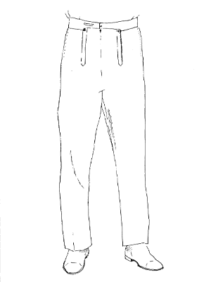
Trousers-9
Description: Trousers, or pantaloons, were the everyday leg wear for most people of Texas. They were usually constructed with wide legs for ease of work and had a gathered seat with either fall front closure. However some had tighter fitting legs (especially among upper class trousers). These were made in a variety of colors, and checked patterns were known to be used as well.
Materials: wool, jean, linen, linsey, Russia sheeting, cotton canvas and some out of buckskin (once again with limited short fringe).
Who Wore It: These were very common wear for everyone. Material and tailoring were the factors that differentiated between the classes.
Period Descriptions:
“Milam's stature being near six feet, the pantaloons thus acquired were at least six inches too short and his sleeves ditto.”

“found that his only injury consisted in a sick stomach caused by a bullet striking and breaking a large Bowie knife which he carried stuck under the waistband of his pantaloons directly in front.” -Noah Smithwick on the Battle of Concepcion

Cossack Trouser-4
Description: Cossack trousers were another type of leg garment that was worn in the 1820’s but was still around in the 30’s and 40’s. However, these tended to be more for people of higher class standings or recent European immigrants. They were constructed similar to trousers, with the exception that the legs were more fitted, and they had a strap that passed under the instep of the wearer’s foot. This could be fastened under the foot to keep the trouser legs in place while putting on boots, or they could be fastened under the instep of the shoe.
Materials: wool, linen, cotton
Who Wore It: Older men, recent immigrants, men of wealth

Calzoneras-1 for Anglos and a 6 for Tejanos
Description: Similar to trousers, the Calzoneras differed in having the outside of the leg seam opened. This could be closed in several ways, either with buttons, ball and chain fasteners, or laced up. Sometimes they had elaborate trim down the seams and hem in a contrasting color. These were typically worn over white calzoncillos (loose underdrawers made of cotton either knee or ankle length) and the bota. These were popular wear for Mexican ranchers and vaqueros. These type of trousers were the mark of a Mexican horseman, and the “style” cam still be seen with the traditional mariachi singers.
Materials: wool, cotton, leather
Who Wore It: Mostly Mexican horsemen and ranchers. Popular style among hispanics due to the association with the Mexican ranching tradition. However, a VERY FEW Anglos may have adopted the style.

Breeches or Riding Breeches-2
Description: Breeches were an item that had generally been in fashion during the 18th century. They were similar to trousers except that they terminated just below the knee and were more closely fitted. The closure under the knee could be closed with buttons, a tie, or a buckle. Both types of fall front closure would have been seen. By this period, only older men or gentlemen (as part of a riding outfit with boots) would have worn these. Tejanos had a similar garment that was worn by horsemen.
Materials: Wool, cotton, linen, and leather
Who Wore It: Older men still clinging to the Revolutionary styles, and wealthy upper class men while riding or as part of a hunting outfit to be worn with boots.

Leggings and Botas
Description: Leggings and botas were a type of lower leg covering, worn by ranchers, horsemen, and hunters. The leggings were an item borrowed from the native American culture. The simplest forms were a hide wrapped around the leg and having a seam sewn up the outside, leaving a flap. This flap could be left as is, or be cut into short fringe. It is very unlikely that the Plains Indian styles, with long twisted or braided fringe was ever worn by Texians during this time period.
Botas were another type of leg covering favored by Mexican ranchers and horsemen. These had probably evolved from the native American legging, but differed in that the bota would be strapped under the knee, and the upper portion of the leather would then be folded down to cover the area. Some were very similar to leggings, differing in the fact that they were folded over, while others were made from thicker tooled leather and had buttons to secure the 2 flaps together. These were generally worn under the calzoneras, showing where the leg had been unbuttoned.

Materials: Generally made out of either buckskin or tooled leather, some leggings were made from wool.
Who wore it: These protective garments could have been worn by anyone while hunting, working outdoors, or campaigning. The use of boots however, would make these items unnecessary.

Shirts-10
Description: Most shirts of this period were of a simple box cut pattern. They were off the shoulder, and styles varied. They could be plain, colored, striped, checked, with collar or without, with ruffles, plain, or pleated fronts, with a standing or a fall collar. White with standing collars and pleated fronts were formal wear.
Materials: Cotton, Linen, light wool, linsey
Who Wore It: Nearly everyone wore a shirt as their primary undergarment. The difference between classes was more of tailored shirts and material types and expense.

Neckwear
Most men of the period worse some sort of neckwear. As you can see from the photo above(two button neck closure and standing collar), many shirts were made so that the person could wear either a stock or cravat. These could be made in a variety of colors and materials. These could be removed or loosened if performing heavy labor.
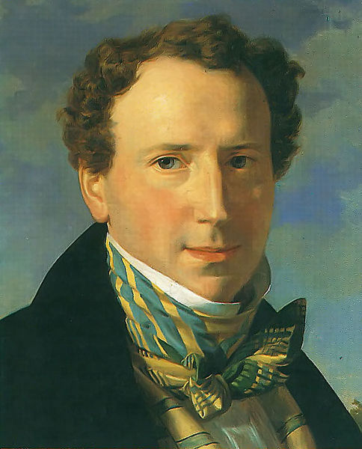
“He was a sharp, spruce-looking buck who might be more readily taken for a country beau than for an ambassador of God. His cravat, thick, and lofty, was tied not tastily and neatly, but in the manner of the latest fashion, while his shirt collar, running to a fine point ,projected up to his eyes like the horns of the new moon, and showing under his ears…”- Mirabeau B. Lamar describing a Methodist preacher in 1835

Cravat-8
Description: The cravat was the neckwear of men during the time period, almost like a necktie today, but more common. It was essentially a piece of cloth 3-6 inches wide, and up to 40 inches long, that would be wrapped around the neck and tied in a variety of ways in the front. This type of neckwear was worn by lower and middle class working people tied in variety of ways. Upper class men also wore these and took great pains in making sure that the tie was in accordance with their status as social elites. The materials varied greatly. The cravat could also be as simple as rolling a handkerchief up and tying it around the neck.
Materials: Typically light materials such as silk, cotton, or linen

Who Wore It: Most men of the period. The way in which it was tied and the quality of the material were usually the variables depending on one’s status and wealth. Upper class gentlemen went to great lengths to ensure that their cravats were tied correctly.

Stock-4
Description: The stock was another type of neckwear that came in a variety of materials and styles. The stock was meant to simulate the cravat, but it buttoned, or hooked together at the back of the wearer’s neck. Some had bows pre-tied onto the front of them. This was very similar to today’s clip on tie.
Materials: Stiffened silk, cotton, linen, and a few in leather
Who Wore It: Middle class shop owners/keepers and a few lower class.

Footwear
While going barefoot was somewhat common among country folk and children as well as being a possibility on campaign (shoes lost or worn out), most people would wear some sort of foot wear even if they were worn out or the wrong size. Several period sources describe individuals that had cut portions of the tops, sides, or fronts of their shoes to allow their foot and toes room. There were several styles that a person could wear.
These are the most prevalent.

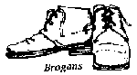
Shoes/Brogans-7
Description: The most common form of footwear during the 1820’s and 30’s was the straight-lasted (no right or left shoe…they are both the same), ankle high brogan. There were several variations to this type of shoe. Most had 3-4 sets of lacing, with the soles being constructed from leather. The soles were either sewn or pegged. Toes were either round or squared. Some even had buckles across the uppers for fitting.

Materials: leather The leather could either be smooth or rough side out, and could be either black or brown.
Who Wore It: These were generally worn by all types of people, of course class and status would effect the construction, wear, and finish.
Period Descriptions:
“There were some of the boys, however, who were not provided with shoes, and moccasins were not adapted to that kind of dancing floor, and moreover they couldn't make noise enough, but their more fortunate brethren were not at all selfish or disposed to put on airs, so, when they had danced a turn, they generously exchanged footgear with the moccasined contingent and gave them the ring.”

“After Dickerson fell asleep, Mc softly arose and stealing the hat and shoes from under his companion's head he carried them, together with his own, a little way aside and hid them in the high grass.”-Noah Smithwick

Boots-4
Description: Generally worn by horsemen or upper-class gentlemen, boots were an alternative to brogans. They were either round or square toed and made from a variety of leather. Most appear to have been constructed with the smooth side out. There are several variations to the tops (area around the knee). Tops could be turned down, or cut in a variety of ways (flat across the top, or with a tab that would protect the knee). Boots also varied in length. Some went to the knees while others only to the calves.
Materials: Generally constructed of leather from several sources. Brown or Black (most popular)
Who Wore It: Ranch hands, horsemen, upper class
Period Descriptions:
“Boots being an unknown quantity; some wore shoes and some moccasins.”-Noah Smithwick

Even though just a little after our period: “boots with short red tops…laced and folded down in such a way as to reach but a little above the ankle, and were finished at the heels with silver spurs. The spurs were, of course, a useless adornment, but they were in those days so commonly worn as to seem almost a part of the boots.”-Francis Lubbock recalling Sam Houston at the 1837 San Jacinto Ball.

Moccasins-4
Description: Moccasins were originally made and worn by the Native Americans. However, due to the ease of construction, and their versatility, many Texians and Tejanos adopted this traditional type of footwear. These were an item that was widely worn, and many early narratives mention people wearing moccasins. There were many variations to this simple footwear, and style probably depended on what the maker was most familiar with (Center Seam, Side Seam, or pucker toe). However, fringe was rarely seen on moccasins worn by Anglos, European immigrants, or Tejanos.
Materials: Buckskin, Indian tanned leather, even raw hides (under extreme circumstances)
Who Wore It: Native Americans, Texians (poor or on campaign), Tejanos (usually a hard-soled variation)
Period Descriptions: See description under Brogans.
“McGeary and a stranger one day rode up, their feet encased in moccasins and their heads covered with rude caps made of a green deerskin”-Noah Smithwick.

Sources

- Alonzo, Armando C. “Tejano Legacy: Rancheros and Settlers in South Texas, 1734-1900”. University of New Mexico Press. 1998
- Braun, Robert A. “Men’s Clothing Worn in the United States “Mineral District.” http://www.geocities.com/old_lead/mensclothing.htm
- Bolton, Herbert Eugene. With the Makers of Texas: A Source Reader in Texas History. American Book Company, 1904.
- “Buckskin and Homespun: Frontier Texas Clothing 1820-1870”. Wind River Press, Austin, TX
- Hardin, Stephen L. Texian Macabre: A Melencholy Tale of a Hanging in Early Houston. Texas A&M University Press. 2007.
- Hogan, William Ransom, The Texas Republic, A Social and Economic History, University of Oklahoma Press, 1969.
- Irving, Washington, A Tour on the Praries. University of Oklahoma Press, 1956.
- Kleffman, Joseph. research paper “Clothing and Garments of the 1830’s.”
- Moore, Stephen L. Eighteen Minutes: The Battle of San Jacinto and the Texas Independence Campaign. Republic of Texas Press. 2004.
- Smithwick, Noah. Evolution of a State or Recollections of Old Texas Days.
http://www.oldcardboard.com/lsj/olbooks/smithwic/otd.htm

Modern Reenactor’s Color Photos

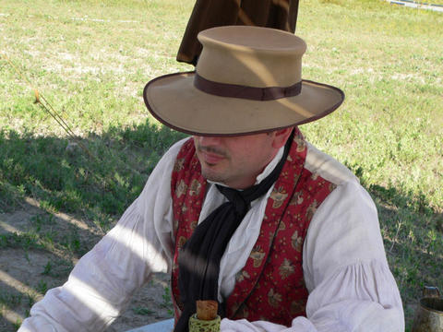
Planters hat, shawl collared vest, and black cravat around wearer’s neck.

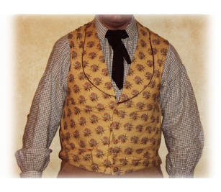
Shawl Collared Vest, simple cravat, and checked shirt

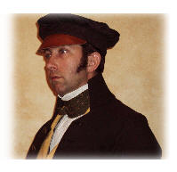
Wheel Cap
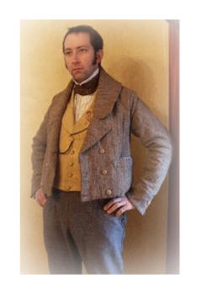Roundabout

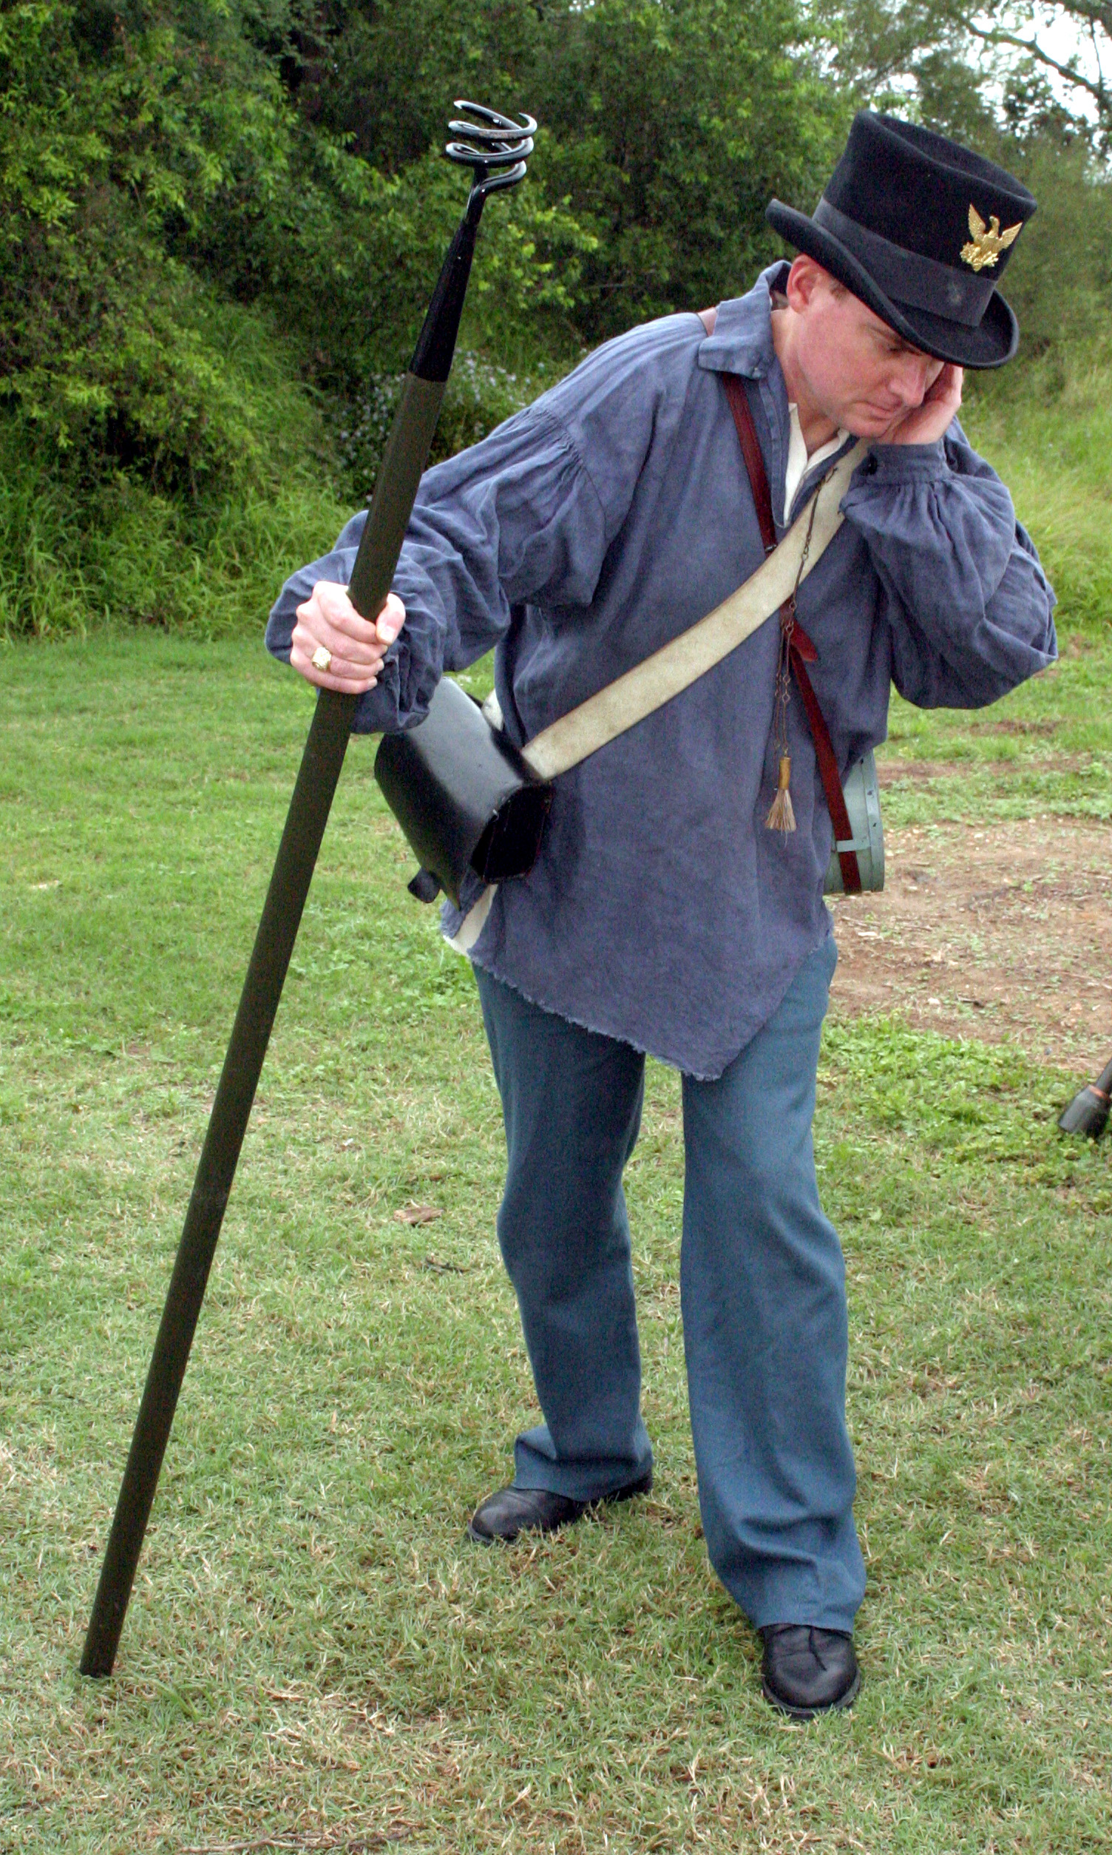
Worn-down top hat and linsey overshirt

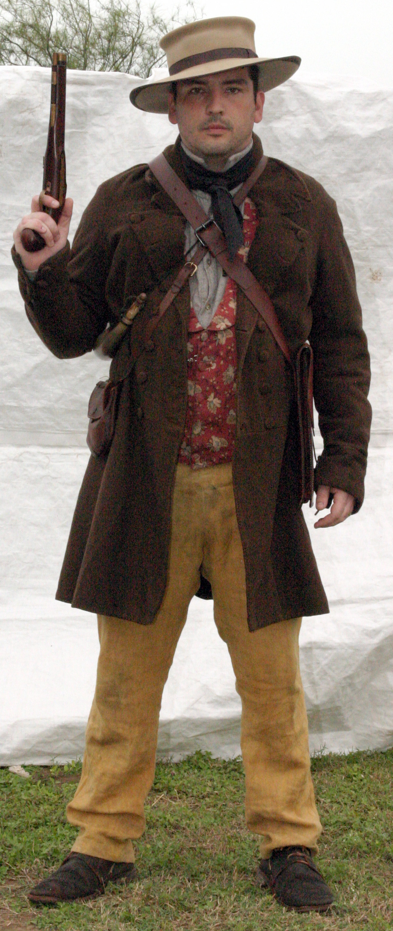
Planter’s hat, Frock Coat, Shawl Collared vest trousers, and brogans.

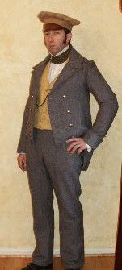
Coatee and trousers of Jean cloth
Shawl colar vest and
wheel cap
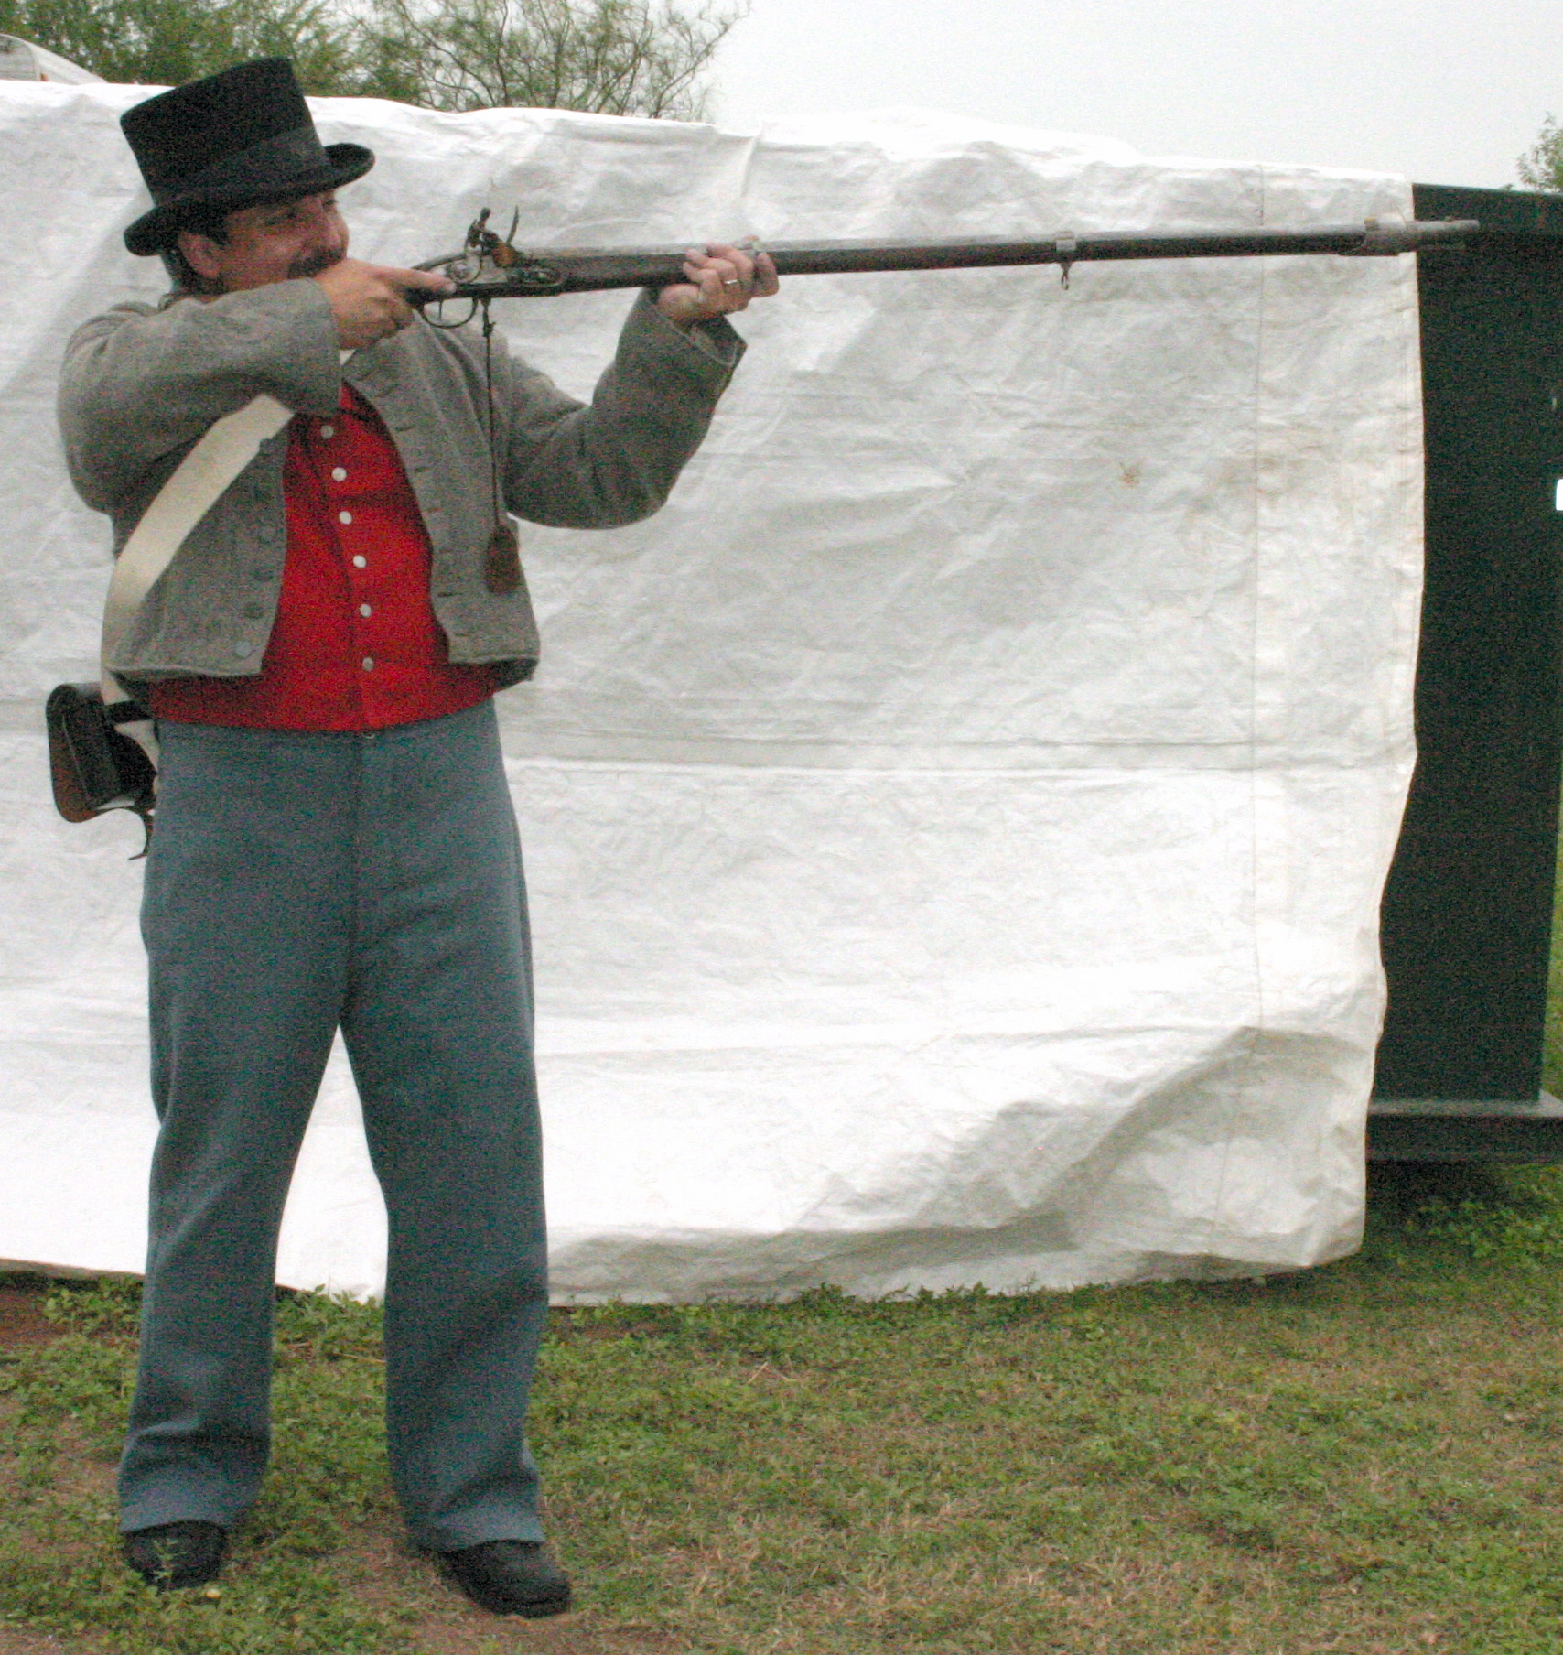
Top Hat, Roundabout, high collar vest, and fly front trousers

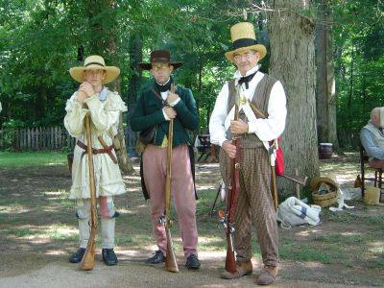
(Left)Hunting Frock with straw hat
(Middle)Slouch hat, tailcoat, Cossack trousers
(End)Straw top hat, vest, trousers

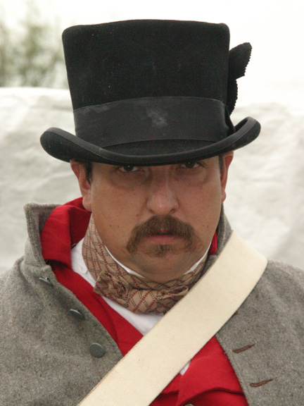
Top hat, pre-tied stock, high collar vest, and roundabout

Vendor’s List for 1820’s and 30’s clothing
Just a note about purchasing items. Some items are going to seem expensive. However, it has been my experience that you get what you pay for. It is better to lay out the initial expense, rather than having to purchase an item twice (due to poor manufacturing). Also check with a member before ordering anything. For one, someone may have the item and sell it to you for a cheaper cost, and secondly to ensure that you are getting the right item. There are also members of the unit that may be able to construct certain garments for you. Also remember that clothing was tailored to fit differently than clothes today (ex: sleeves were tight on some articles, the waist was near your navel, etc…).
- Blockade Runner-Carries Civil War gear. However some items are OK for our period. CHECK WITH A MEMBER BEFORE ORDERING http://www.blockaderunner.com/
- Clearwater Hat Company- Great Hats http://www.clearwaterhats.com/
- Custom Vestments-Company owned and operated by Josef Kleffman and Su Miller. They do a superb job. Custom tailoring at the right price. Joe is also a member of the unit. If it is a clothing item he can make it.
  - http://www.customvestments.com/
- Dirty Billy’s Hats-Customer service is not all that, but they make pretty good hats. Takes a while. http://www.dirtybillyshats.com/
- Just Sara- Economy based clothing to help get started. She does mostly 18th century, but can doe 19th century trousers justsara@up.net
- Missouri Boot and Shoe Company-Period footwear.
  - http://www.missouribootandshoe.com/index.asp
- Steve Abolt The Alleghany Arsenal-Steve does not have a website, but you can contact him through his email. Does excellent work. ‎ sacbg7@lynchburg
- Tim Bender Hats-Quality period hats, and a really great guy to work with.
  - http://www.benderhats.com/

Smithwick, Noah. Evolution of a State or Recollections of Old Texas Days.
Smithwick, Noah. Evolution of a State or Recollections of Old Texas Days.
Hardin, Stephen L. Texian Macabre: A Melencholy Tale of a Hanging in Early Houston
Kleffman, Joseph, “Clothing and Garments of the 1830’s”
“Buckskin and Homespun: Frontier Texas Clothing 1820-1870”. *****Sometimes we all wear “new” items or take care of our (reenactment) clothes and gear so that they show very little use or wear and look as though we have just stepped out of a costume plate. Worn and repaired clothing is VERY APPROPRIATE. Don’t be afraid to use your items.
Hogan, William Ransom, The Texas Republic, A Social and Economic History
Smithwick, Noah. Evolution of a State or Recollections of Old Texas Days
Moore, Stephen L. Eighteen Minutes: The Battle of San Jacinto and the Texas Independence Campaign
Kleffman, Joseph “Clothing and Garments of the 1830’s.”
“Buckskin and Homespun: Frontier Texas Clothing 1820-1870”.
Smithwick, Noah. Evolution of a State or Recollections of Old Texas Days
Alonzo, Armando C. “Tejano Legacy: Rancheros and Settlers in South Texas, 1734-1900”.
Smithwick, Noah. Evolution of a State or Recollections of Old Texas Days
Alonzo, Armando C. “Tejano Legacy: Rancheros and Settlers in South Texas, 1734-1900”.
Smithwick, Noah. Evolution of a State or Recollections of Old Texas Days
Alonzo, Armando C. “Tejano Legacy: Rancheros and Settlers in South Texas, 1734-1900”.
Alonzo, Armando C. “Tejano Legacy: Rancheros and Settlers in South Texas, 1734-1900”.
“Buckskin and Homespun: Frontier Texas Clothing 1820-1870”.
“Buckskin and Homespun: Frontier Texas Clothing 1820-1870”., Hogan, William Ransom, The Texas Republic, A Social and Economic History
Kleffman, Joseph, “Clothing and Garments of the 1830’s”
Smithwick, Noah. Evolution of a State or Recollections of Old Texas Days
Smithwick, Noah. Evolution of a State or Recollections of Old Texas Days
Hogan, William Ransom, The Texas Republic, A Social and Economic History
Hogan, William Ransom, The Texas Republic, A Social and Economic History
Smithwick, Noah. Evolution of a State or Recollections of Old Texas Days
Irving, Washington, A Tour on the Praries
“Buckskin and Homespun: Frontier Texas Clothing 1820-1870”.
Moore, Stephen L. Eighteen Minutes: The Battle of San Jacinto and the Texas Independence Campaign
Moore, Stephen L. Eighteen Minutes: The Battle of San Jacinto and the Texas Independence Campaign
Smithwick, Noah. Evolution of a State or Recollections of Old Texas Days
Bolton, Herbert Eugene. With the Makers of Texas: A Source Reader in Texas History
Smithwick, Noah. Evolution of a State or Recollections of Old Texas Days
“Buckskin and Homespun: Frontier Texas Clothing 1820-1870”.
Smithwick, Noah. Evolution of a State or Recollections of Old Texas Days
Smithwick, Noah. Evolution of a State or Recollections of Old Texas Days
“Buckskin and Homespun: Frontier Texas Clothing 1820-1870”.
Smithwick, Noah. Evolution of a State or Recollections of Old Texas Days

